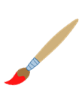
Little Promises Twos Class
2023/2024 Supply List
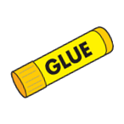
All Students:
(Parents must label with their child’s name)
- Backpack (big enough to hold folder/papers & change of clothes)
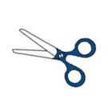
- Reusable water bottle (*no sippy cups*)
- Ziplock bag with change of clothes
- Diapers and wipes (*if needed)
- 2 glue bottles
- Fabric bandaids
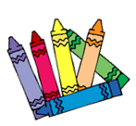
- 1 pack of thin markers
- 1 pack of dry erase markers

Classroom Supply List OR $30 Supply Fee:
(Bring to Back-to-School Night)
- 2- packs of baby wipes
- 2- rolls of paper towels
- 1- package of papers
- 1- box of trash bags - kitchen size
- 1- box of tissues
- 1- pack of gallon ziplock bags
- 1- container of disinfectant wipes

Wish List Items: (Request that parents send in 2 items from below list)

- Magnet tape
- Velcro Dots
- 1 Pack of highlighters
- Thick popsicle sticks
- Noodles (Penne and Spaghetti)
- Glitter Pens
- Mini Pom poms
- Large Googly Eyes
- Stamp ink pads
- Tape
- Cardstock (any color)
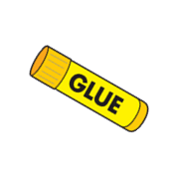
- Jumbo alphabet stamps
- Cotton balls
- Shaving Cream
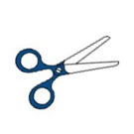
- Food Coloring
- Feathers
- Baking soda

