Little Promises Fours Class
2023/2024 Supply List
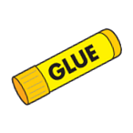
All Students:
(Parents must label with their child’s name)
- Backpack (big enough to hold folder/papers & change of clothes)
- Reusable water bottle
- Ziplock bag with change of clothes
- Box of colored pencils
- Playdough
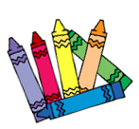
- 1 pack big pencils
- 1- pack thin washable markers
- 2- pack of glue sticks

Classroom Supply List OR $30 Supply Fee:
(Bring to Back-to-School Night)
- 1- pack of baby wipes
- 2- rolls of paper towels
- 1- bottle of white Elmer’s glue
- 1- pack of coffee filters
- 1- pack of construction paper
- 1- box of tissues
- 1- container of disinfectant wipes
- 1- box gallon size ziplock bags
- 1- bottle of hand soap
- Black permanent markers
- Black dry erase markers
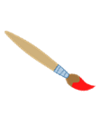

Wish List Items:
(Request that parents send in 2 items from below list)
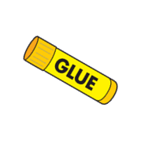
- Plain white paper plates
- Pipe cleaners
- Thick popsicle sticks
- Googly Eyes
- Tissue paper (any color)
- Buttons
- Stickers
- Cardstock (any color)
- Pom poms
- Stamp ink pads
- Hot glue sticks (small or medium)
- Small paper cups

